# Day 3 Activities

## Activity #1 – Create PECI Integration

* + 1. Locate the task **Create Integration System**.
    2. Enter *YOUR NAME-PECI* as the System Name.
    3. Select **New using Template** then use to the prompt to select **Payroll Effective Change Interface**.
    4. Click **OK**. The Configure Integration Services page lists the required services enabled by default. How do these required services differ from those in PI?
    5. Click **OK** to save the integration system.
    6. Using the **Configure Integration Attributes** related action:
       1. Select **United States of America** as the Payroll Country.
       2. Select **UNKNOWN** as the Payroll Vendor.
    7. Click **OK** to save.

CREATE AN INTEGRATION SYSTEM USER

Create an integration system user with Payroll Interface System security group permissions and associate it with the YOUR NAME-PECI integration system.

## Activity #2 – Full file for PECI

1. Launch the YOUR NAME-PECI Integration with the following settings:

|  |  |
| --- | --- |
| ***Field Name*** | ***Entry Value*** |
| Pay Group | Third Party – Green Planet Acquisition |
| Pay Period Selection Option | Use Pay Period for Current Date |
| Full Snapshot | Yes |

1. When the integration completes, open the XML output tagged Deliverable and review XML structure. How does this output differ from the full extract generated by the PI integration system in Activity 3.2?

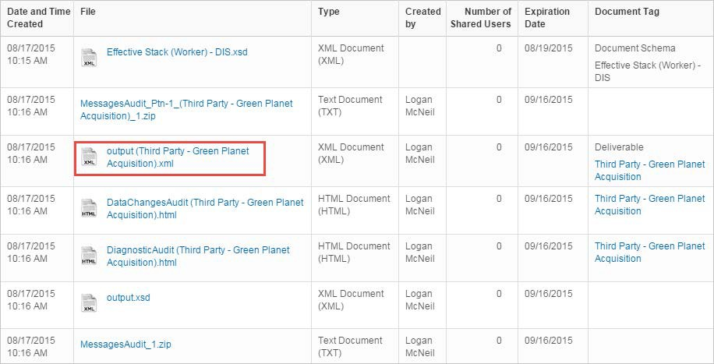

## Activity #3 – Change Worker Data

1. Locate worker **Laurie Jenkins** and click her Related Actions > **Personal Data** > Edit Personal Information**.**
2. Change her Martial Status from Married to **Divorced**.
3. Set the Marital Status Date as 2 days ago.
4. Click **Submit**.
5. Launch the YOUR NAME-PECI integration system with the following launch parameters:

|  |  |
| --- | --- |
| ***Field Name*** | ***Entry Value*** |
| Pay Group | Third Party – Green Planet Acquisitions |
| Pay Period Selection Option | Use Pay Period for Current Date |
| Change Detection | Include only changes since last successful run |
| Last Successful Run Date | Start time of class today |

1. What does the output show? Why do Marital Status and Marital Status Date display?

## Activity #4 – Additional Worker Data Changes

* + 1. Locate Laurie Jenkins and click her Related Actions > **Personal Data** > **Edit Personal Information**.
    2. Change her Marital Status from Divorced to **Married**.
    3. Set the Marital Status Date as today’s date.
    4. Click **Submit**.
    5. Launch the YOUR NAME-PECI integration system with the following launch parameters.

|  |  |
| --- | --- |
| ***Field Name*** | ***Entry Value*** |
| Pay Group | Third Party – Green Planet Acquisitions |
| Pay Period Selection Option | Use Pay Period for Current Date |
| Change Detection | Include only changes since last successful run |
| Last Successful Run Date | Start time of class today |

* + 1. What does the output look like now? How would it look different if the system were Payroll Interface?

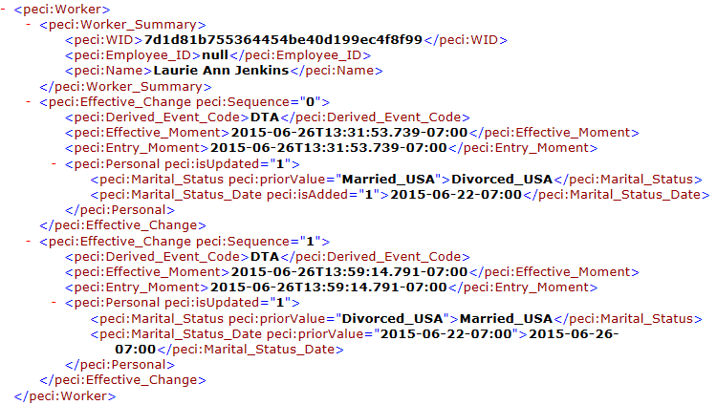

## Activity #5 – Set last extract created date and schedule primary integration

**SET LAST EXTRACT CREATED DATE**

* + 1. Locate the task **Maintain Payroll Integration Systems for Pay Group**.
    2. Select **Third Party – Green Planet Acquisition**, then click **OK**.
    3. Click the plus and add **YOUR NAME-PECI** Integration System.
    4. Set the Created Date Time as *12:00:00 AM* on the last day of last month.
    5. Click **OK**.

**SCHEDULE PRIMARY INTEGRATION**

1. From the YOUR NAME-PECI integration, select the **Launch / Schedule Integration**

related action.

1. Select **Weekly Recurrence** as Run Frequency.
2. Click **OK**.
3. Configure the Integration Criteria as follows:

|  |  |
| --- | --- |
| ***Field Name*** | ***Entry Value*** |
| Pay Group | Third Party – Green Planet Acquisitions |
| Pay Period Selection Option | Use Earliest Open Pay Period |
| Primary Run | Yes |

1. Click the **Schedule** tab and enter the following:

|  |  |
| --- | --- |
| ***Field Name*** | ***Entry Value*** |
| Recurs Every x Week(s) | 1 |

|  |  |
| --- | --- |
| Day(s) of the Week | Wednesday |
| Start Time | 3:00 AM |
| Time Zone | Pacific Time |
| Start Date | Wednesday of next week |
| End Date | Last day of the year |

1. Click **OK**.
2. Locate the **Scheduled Future Processes** report and note the YOUR NAME-PECI integration.

## Activity #6 – PECI Name and Address Change

* 1. For worker: Laurie Jenkins, change the legal name.
  2. Change the Last Name from Jenkins to *Chiang*.
  3. Click **Submit**.
  4. For worker: Laurie Jenkins, change contact information.
  5. Click **Edit** within the Home Contact Information Primary Address section.
  6. Modify Address Line 1 to be *300 North Lake Shore Drive*.
  7. Delete the value in Address Line 2.
  8. Click **Submit**.

1. From the YOUR NAME-PECI integration, **Configure Integration Attributes** to select

**Home** as the Address Usage Type.

1. Click **Configure Integration Field Attributes** and select the boxes for Personal Data Section **and** Person Communication Data Section**.**
2. Click the **Personal Data Section** folder.
3. Click the box to include **Legal Name**.
4. Click the **Legal Name** subsection.
5. Include the **First Name**, **Middle Name**, and **Last Name** fields.
6. Click the **Person Communication Data Section** folder.
7. Click the box to include **Address**.
8. Click the **Address** subsection.
9. Include the fields: **Usage Type, Address Line 1/2/3/4, City, Postal Code, Country, Country Region.**
10. Launch the integration with the following settings:

|  |  |
| --- | --- |
| ***Field Name*** | ***Entry Value*** |
| Pay Group | Third Party – Green Planet Acquisitions |
| Pay Period Selection Option | Use Pay Period for Current Date |
| Change Detection | Include only changes entered since the LSR |
| Last Successful Run Date | Keep the default value |

## Activity #7 – PECI Personal Data: Indentifiers

EDIT NATIONAL ID AND RUN INTEGRATION

* + 1. Click Nicolas Bonnet’s Related Actions and select **Personal Data** > **Edit ID Information.**
    2. Delete the Identification # and enter *1-51-02-46-102-043-25.*
    3. Note the National ID Type is Social Security ID (INSEE) Number.
    4. Click **Submit**.
    5. From the YOUR NAME-PECI integration system, click **Configure Field Attributes**.
    6. Include the **Personal Identification Data Section** and subsections for National Identifier **and** Passport Identifier**.**
    7. **Include all fields** for National Identifier and Passport Identifier.
    8. Click **Configure Integration Maps** and select the National ID Type internal value of **France** > **Social Security (INSEE) Number**.
    9. Map the external value as *INSEE.*
    10. Launch the integration with the following settings:

|  |  |
| --- | --- |
| ***Field Name*** | ***Entry Value*** |
| Pay Group | FRA Monthly |
| Pay Period Selection Option | Use Pay Period for Current Date |
| Change Detection | Include only changes entered since the LSR |
| Last Successful Run Date | Leave the default value |

* + 1. Observe which data sections are included for Nicolas in the output. Note the Passport ID Type.

MAP PASSPORT ID AND LAUNCH INTEGRATION

1. Navigate to Nicolas’s Personal IDs and click the Related Actions off of the Passport ID Type **Standard** > **Integration IDs** > **View IDs**.

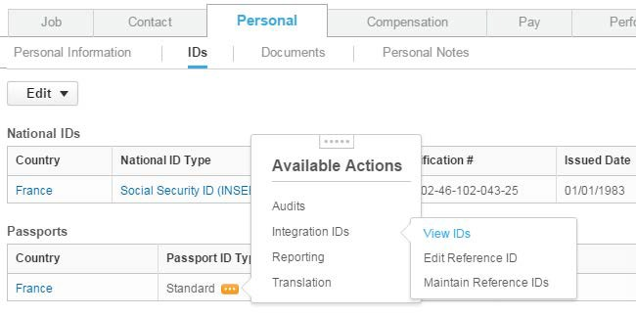

1. Note that the Passport ID Type observed in the output is a Reference ID.
2. From the YOUR NAME-PECI system, **Configure Integration Maps** for the Passport ID by locating the Identifier Type field and selecting the internal value **Passport ID**

> **Standard**.

1. Map the external value as *STD*
2. Launch integration again with a LSRD from before the ID change.

|  |  |
| --- | --- |
| ***Field Name*** | ***Entry Value*** |
| Pay Group | FRA Monthly |
| Pay Period Selection Option | Use Pay Period for Current Date |
| Change Detection | Include only changes entered since the LSR |
| Last Successful Run Date | Time before the ID change |

## Activity #8 – PECI Position Data: Organizations

CHANGE ORGANIZATION FOR EMPLOYEE

* + 1. From Nicolas’s Related Actions select **Organization** > **Change Organization Assignments**.
    2. Keep the Effective Date as today.
    3. Change the Region to Europe.
    4. Click **Submit**.

INTEGRATION CONFIGURATION AND LAUNCH

1. Configure the **Organization Type for Organization** attribute to include the following organizations: **Region** and **Supervisory**.
2. View the **Integration Maps** to determine if mapping is required for Organization**.**
3. Configure all Position and Organization fields to be included in the output.
4. Launch the integration for France using the same settings as the prior runs.

## Activity #9 – PECI Position Data: Organizations

* + 1. Locate the integration event from Activity 8 and click the **Output Files** tab.
    2. Open the **Data Changes Audit.**
    3. Review how the added and deleted cost center fields are represented.
    4. Open the **Diagnostic Audit**.